LAB 6: Symbolic Mathematics in MATLAB
Objectives:
• Familiarizing students with the symbolic math toolkit in MATLAB
Lab Tasks:
1. Differentiate the following expression:
𝑒−2𝑏𝑦 ∗ 𝑦4𝑎 ∗ cos(𝑐𝑦)
Simplify your answer.
ANSWER:

clc
clear All
syms b c y a;

% Define the function
f = exp(-2*b*y) * y^(4*a) * cos(c*y);

% Differentiate the function
df = diff(f, y);

% Simplify the result
df_simplified = simplify(df);

% Display the simplified result
disp(df_simplified);

RESULT:
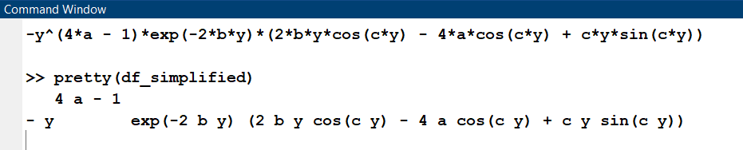
2. Integrate the following expression:
𝑒−2𝑎𝑥 ∗ sin(𝑏𝑥)
Simplify your answer.
ANSWER:

syms a b x;

% Define the function
f = exp(-2*a*x) * sin(b*x);

% Integrate the function
int_f = int(f, x);

% Simplify the result
int_f_simplified = simplify(int_f);

% Display the simplified result
disp(int_f_simplified); %% In command window type pretty(int_f) to get a more simplified

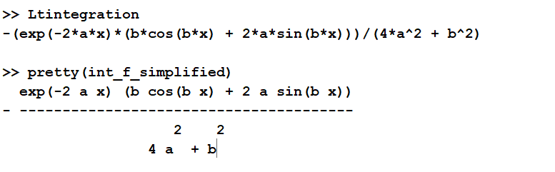
RESULT:

3. Integrate the following expression within the given limits:
∫ [𝑒−2𝑏𝑦 ∗ cos(𝑐𝑦)] 𝑑𝑦
+𝜋 to −𝜋
Simplify your answer.
ANSWER:
syms a y;

% Integrate the function
int_f = int(cos(a*y), y);

% Substitute a = 2 and y = pi/4
int_f_sub = subs(int_f, {a, y}, {2, pi/4});

% Evaluate the numeric result
result = double(int_f_sub);

% Display the result
disp(result);

RESULT:
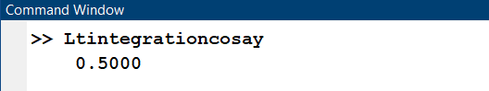
4. Create the following function in MATLAB:
𝑒^{cos(𝑐𝑦)}
Plug in values to get definite answer.
ANSWER:

c = 2; % Example value for c
y = 0.5; % Example value for y

result = e_cos_cy(c, y);
disp(result);

function result = e_cos_cy(c, y)
result = exp(cos(c*y));
end

RESULT:
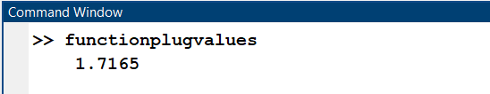

5. Integrate the given expression:
∫ [𝑒−2𝑏𝑦 ∗ cos(𝑐𝑦)] 𝑑𝑦
+𝜋 to−𝜋
Substitute b = 3 and c = 5 after integration to get the results.
ANSWER:
syms a b c y;

% Define the function
f = exp(-2*b*y) * cos(c*y);

% Integrate the function with limits
int_f = int(f, y, -pi, pi);

% Substitute b = 3 and c = 5
int_f_sub = subs(int_f, {b, c}, {3, 5});

% Simplify the result
int_f_simplified = simplify(int_f_sub);

% Display the simplified result
disp(int_f_simplified);

RESULT:
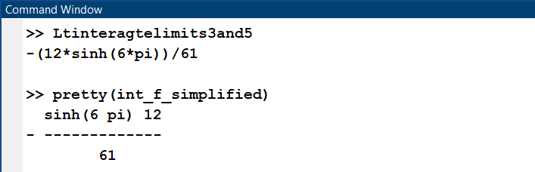
6. Integrate the following expression:
cos(𝑎 ∗ 𝑦)
Evaluate the numeric results for fixed variables after integration.
ANSWER:
syms a y;

% Integrate the function
int_f = int(cos(a*y), y);

% Substitute a = 2 and y = pi/4
int_f_sub = subs(int_f, {a, y}, {2, pi/4});

% Evaluate the numeric result
result = double(int_f_sub);

% Display the result
disp(result);

RESULT:
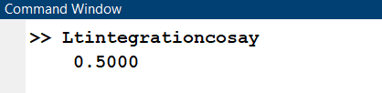

Introduction to Symbolic Equations and Their Solutions in MATLAB
Lab Tasks:
1. Plot the following equation.
𝑥2 + 𝑦2 = 9
Use lhs equation to shift the variables to the left.
ANSWER:
clc
clear
lhs = 'x^2+y^2-9';
ezplot(lhs,[-4,4,-4,4]);
axis square

RESULT:
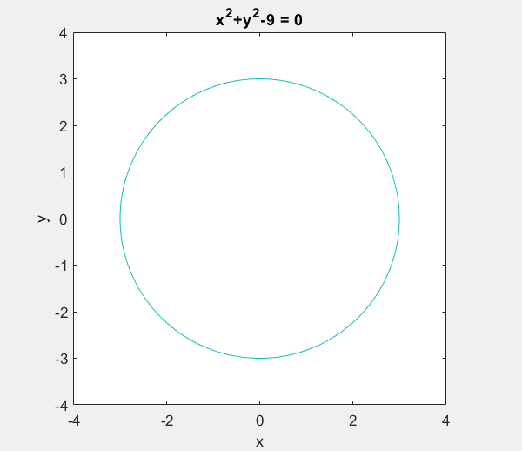

2. Take a vector from x=-5:5 and calculate e(3x-6).
Repeat the same by using Symbolic Mathematics.
Plot by using ezplot command.
ANSWER:
x=-5:5;
f=exp(3*x-6);

%%using symbolic
syms t
e=exp(3*t-6);
ezplot(e);

RESULT:
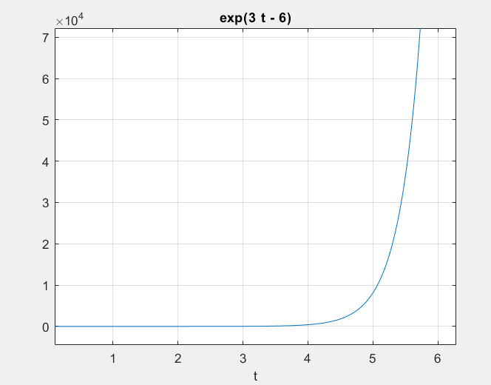
3. Use MATLAB to solve the following systems of simultaneous equations:
6x - 3y + 8z =10
-9x +7y +3z = 2
x +2y +6z = -5
ANSWER:
A = [6, -3, 8; -9, 7, 3; 1, 2, 6];
b = [10; 2; -5];
x = A \ b;
disp('Solution (x, y, z):');
disp(x);

RESULT:
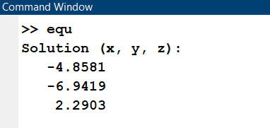
4. Evaluate the following expression:
Σ(2 ∗ 𝑘)/𝑘² k=0 to ∞
ANSWER:
% Define the range of k values
k_values = 1:100; % You can adjust the range as needed

% Initialize the sum
sum = 0;

% Iterate over k values and accumulate the sum
for k = k_values
sum = sum + (2*k) / k^2;
end

% Display the result
disp(sum);

RESULT:
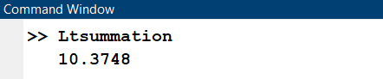

5. Evaluate the following expression:
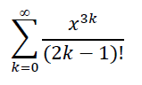
ANSWER:
syms x; % Declare x as a symbolic variable
% Define the range of k values
k_values = 1:10; % You can adjust the range as needed
% Initialize the sum
sum = 0;
% Iterate over k values and accumulate the sum
for k = k_values
if k >= 1 % Check if k is non-negative
term = (x^(3*k)) / factorial(2*k - 1);
sum = sum + term;
end
end
% Display the result
disp(sum);

RESULT:
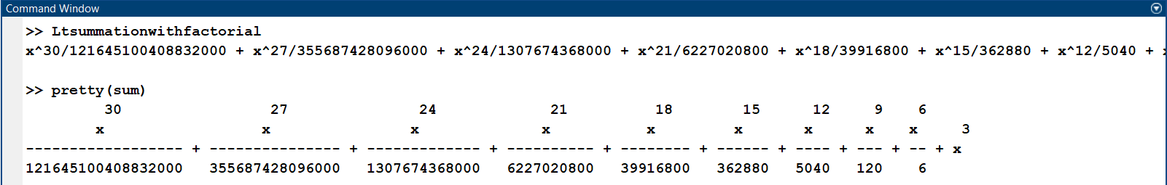
6. Use symbolic mathematics to prove the following identity:
𝑠𝑖𝑛2(𝑥) + 𝑐𝑜𝑠2(𝑥) = 1
Plot your solution using ezplot.
ANSWER
syms x;
% Define the expression
expr = sin(x)^2 + cos(x)^2;
% Plot the expression
ezplot(expr, [-2*pi, 2*pi]); % Plot over the range from -2? to 2?
title('Plot of sin^2(x) + cos^2(x)');
xlabel('x');
ylabel('sin^2(x) + cos^2(x)');

% Check the identity
if simplify(expr) == 1
disp('The identity is proven.');
else
disp('The identity is not proven.');
end
not proven.');
end

RESULT:


